Yalla Kora Bugs on Iphone 12 IOS14.3
- Issue Summary (Calendar is not getting closed)
- Open Yalla Kora
- Navigate to “مبارايات ”
- Click on Calendar icon the upper right top
- Close button is missing and when try to close it by touching any empty space it is not getting closed
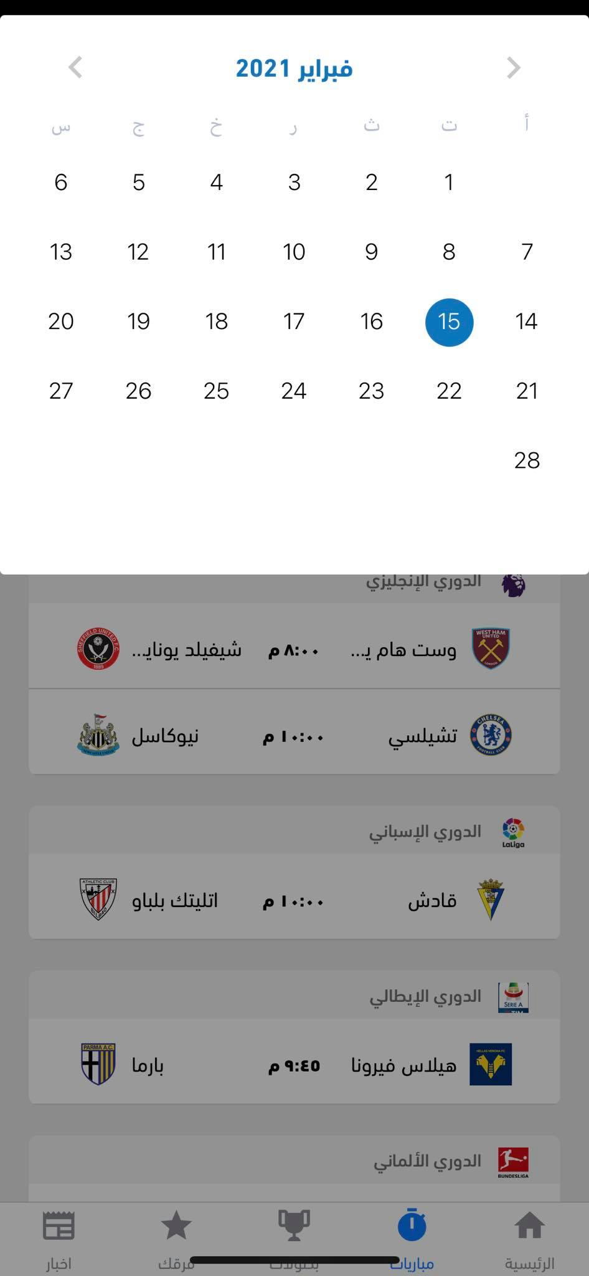

- Issue Summary (Calendar icon does not get clicked easily) Due to I-phone notch
  - Open Yalla Kora
  - Navigate to “مبارايات”
  - Click on calendar icon the upper right top
  - Expected result icon is easy to click
  - Actual result Icon is not easy to click and does not get clicked from the 1st time
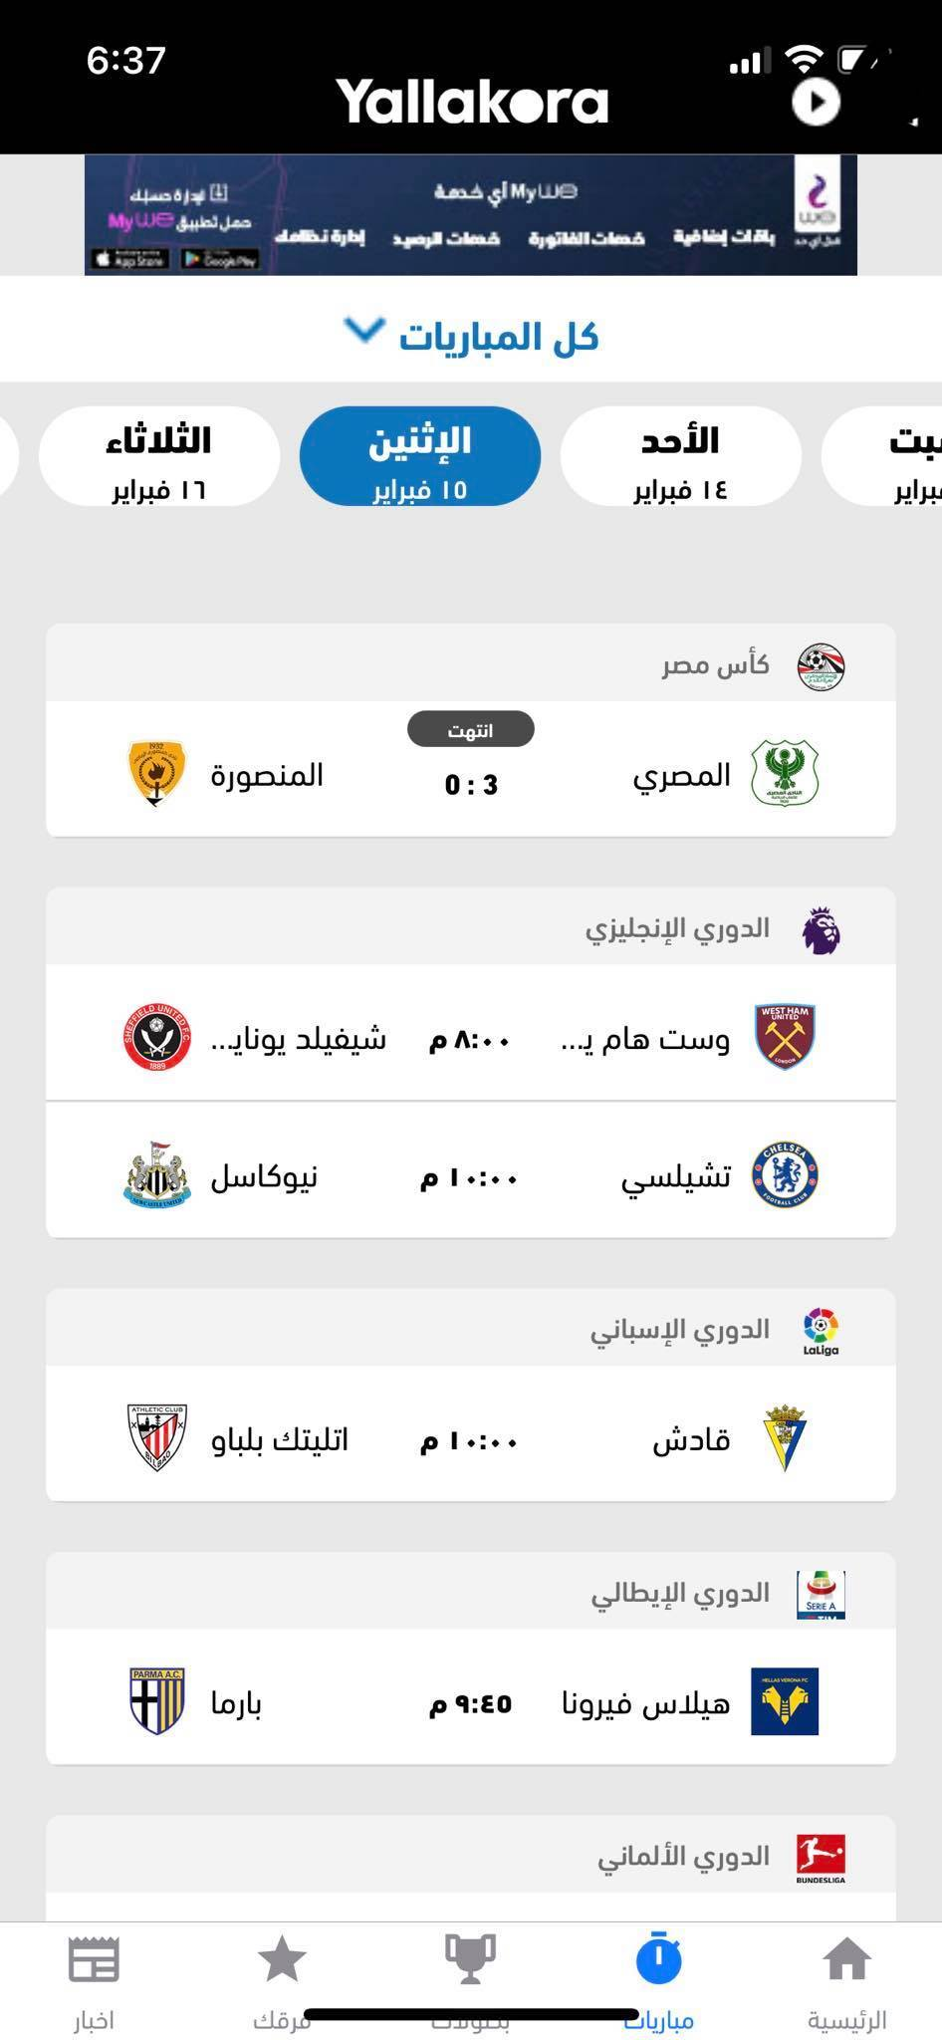
- Issue summary (Calendar is hiding status bar )
  - Open yalla kora
  - Navigate to “مبارايات”
  - Click on calendar icon in the upper right corner
  - Expected result calendar is opened successfully under the status bar
  - Actual result calendar is opened but it hides the status bar


- Issue summary (Missing Logo)
  - Open yalla kora
  - Navigate to “بطولات ”
  - Expected result Championships are listed with their Logos
  - Actual result All Championships are listed with their logos except “تصفيات كاس العالم – اوروبا ”
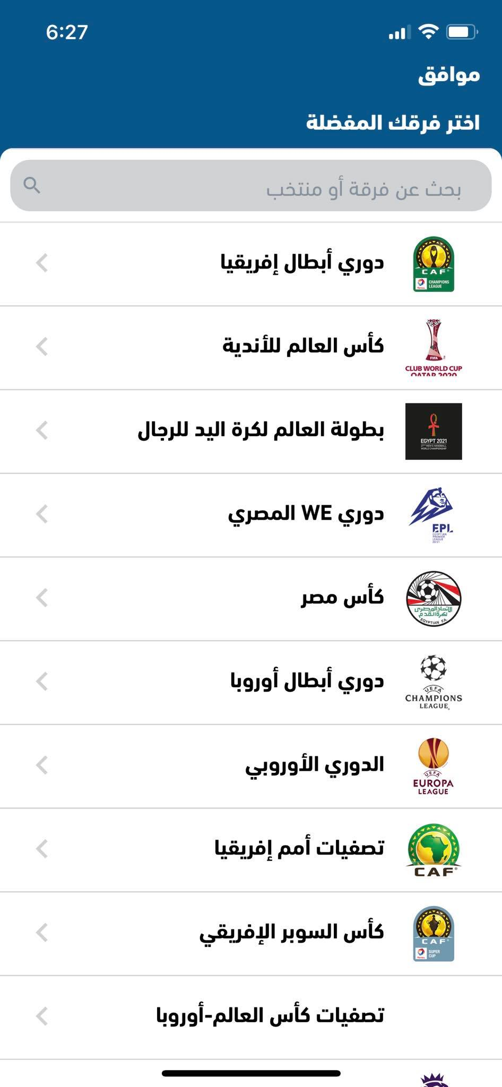
- Issue summary (Iphone 12 home bar covers Yalla kora tabs )
  - Open Yalla kora
  - Expected result All the bottom icons are displayed successfully
  - Actual result Iphone 12 home bar covers Yalla kora tabs

- Issue summary (Player is duplicated in two different teams )
  - Open Yalla kora
  - Navigate to “بطولات”
  - Navigate to “الدوري النجليزي”
  - Navigate to “الاحصائيات ”
  - Navigate to “كل الهدافين ”
  - Expected result All players scored are listed with no duplicated
  - Actual result Lingard is duplicated in two different teams
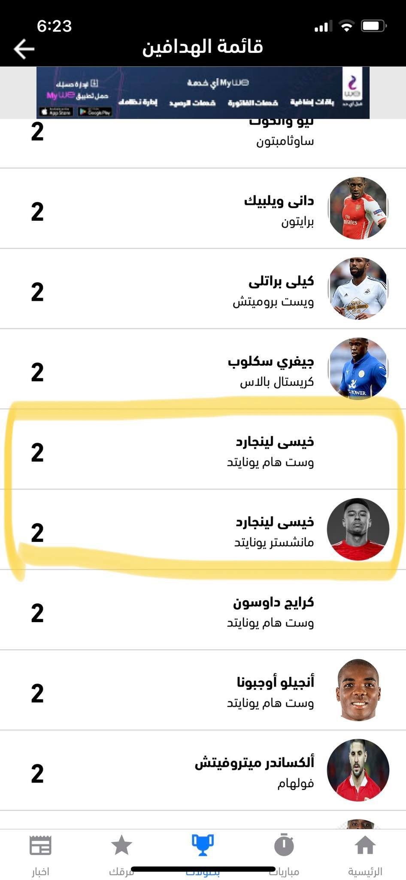

- Issue summary (Click on team in today’s matches result to no internet connection)
  - Open Yalla Kora
  - Navigate to “الرئيسيه ”
  - Click on “المصري المنصوره ”match
  - Click on “المنصوره ”
  - Expected result Teams is opened successfully
  - Actual result No Internet
Note while click on the other team it is working normally

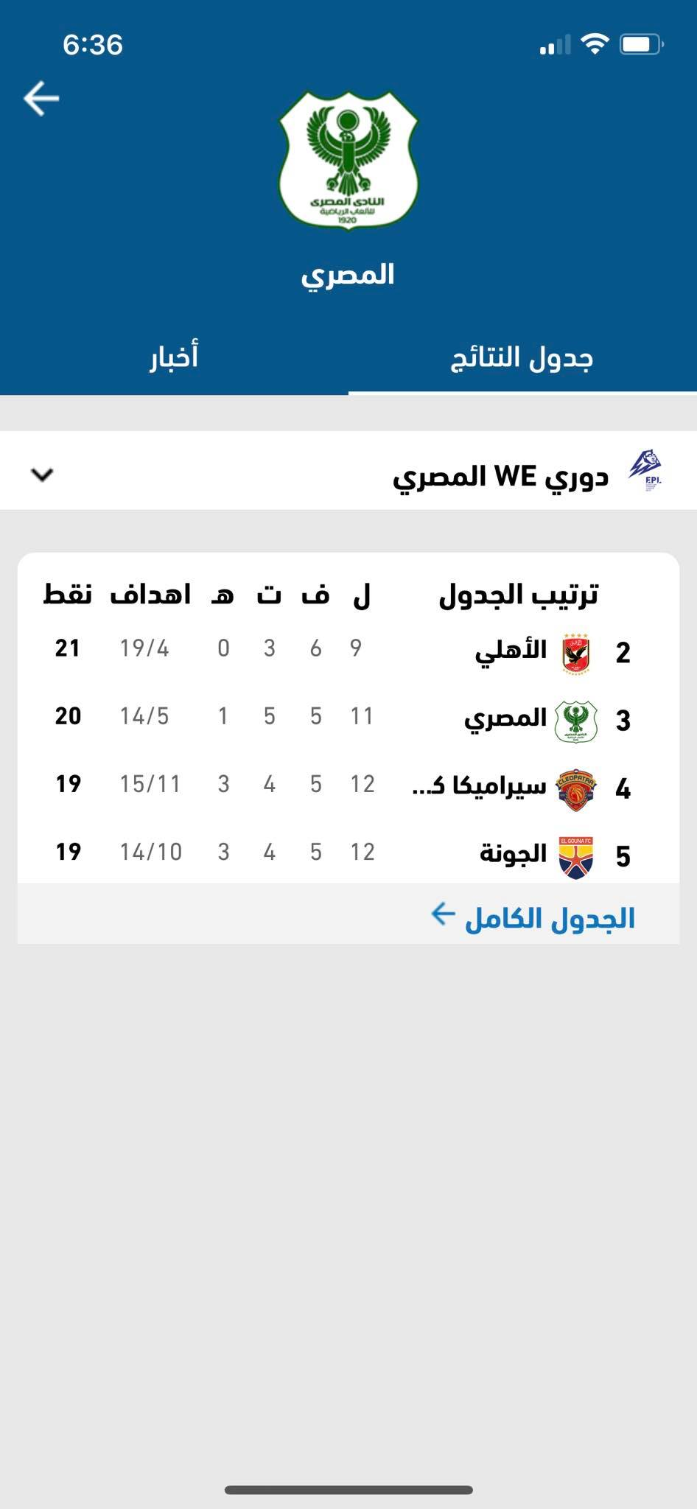

- Issue summary (Adding “تيجيريس اونال”to your favorite team crashes the app)
  - Open Yalla kora
  - Navigate to “فرقك”
  - Click on + icon
  - Navigate to “كاس العالم للانديه”
  - Choose “تيجيريس اونال”
  - Click on “موافقه ”
  - Expected result Team is added to your favorite teams
  - Actual result Application freeze on white screen and “فرقك” is not opening again by getting stuck to the white screen
Note no screenshot is added here as it will not appear in the document

